

AP® Physics C
1984 Free Response Questions

The materials included in these files are intended for use by AP teachers for course and exam preparation in the classroom; permission for any other use must be sought from the Advanced Placement Program®. Teachers may reproduce them, in whole or in part, in limited quantities, for face-to-face teaching purposes but may not mass distribute the materials, electronically or otherwise. These materials and any copies made of them may not be resold, and the copyright notices must be retained as they appear here. This permission does not apply to any third-party copyrights contained herein.

These materials were produced by Educational Testing Service® (ETS®), which develops and administers the examinations of the Advanced Placement
Program for the College Board. The College Board and Educational Testing Service (ETS) are dedicated to the principle of equal opportunity, and their
programs, services, and employment policies are guided by that principle.

The College Board is a national nonprofit membership association dedicated to preparing, inspiring, and connecting students to college and opportunity.
Founded in 1900, the association is composed of more than 4,200 schools, colleges, universities, and other educational organizations. Each year, the
College Board serves over three million students and their parents, 22,000 high schools, and 3,500 colleges, through major programs and services in
college admission, guidance, assessment, financial aid, enrollment, and teaching and learning. Among its best-known programs are the SAT®, the
PSAT/NMSQT®, and the Advanced Placement Program® (AP®). The College Board is committed to the principles of equity and
excellence, and that commitment is embodied in all of its programs, services, activities, and concerns.

APIEL is a trademark owned by the College Entrance Examination Board. PSAT/NMSQT is a registered trademark jointly owned by the College Entrance Examination Board and the National Merit Scholarship Corporation. Educational Testing Service and ETS are registered trademarks of Educational Testing Service.
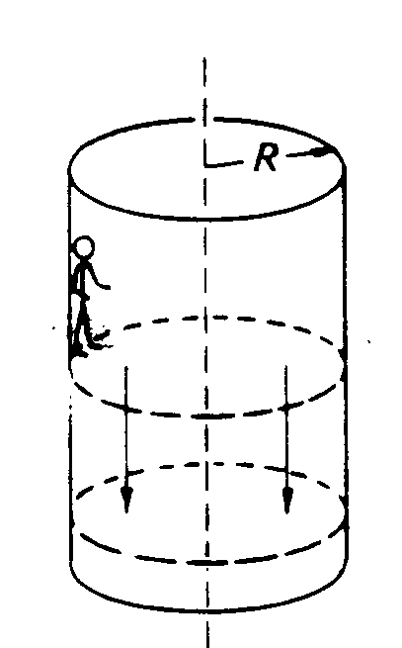
1984M1. An amusement park ride consists of a rotating vertical cylinder with rough canvas walls. The floor is initially about halfway up the cylinder wall as shown above. After the rider has entered and the cylinder is rotating sufficiently fast, the floor is dropped down, yet the rider does not slide down. The rider has mass of 50 kilograms, the radius R of the cylinder is 5 meters, the angular velocity of the cylinder when rotating is 2 radians per second, and the coefficient of static friction between the rider and the wall of the cylinder is 0.6.
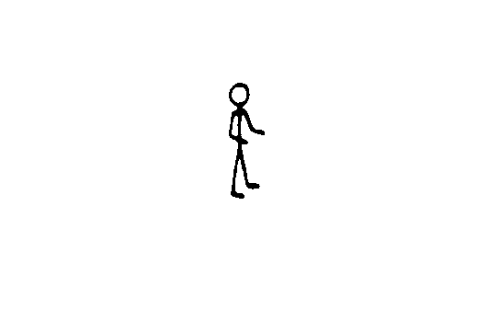
a. On the diagram below. draw and identify the forces on the rider when the system is rotating and the floor has dropped down.
b. Calculate the centripetal force on the rider when the cylinder is rotating and state what provides that force.
c. Calculate the upward force that keeps the rider from falling when the floor is dropped down and state what provides that force.
d. At the same rotational speed, would a rider of twice the mass slide down the wall? Explain your answer.

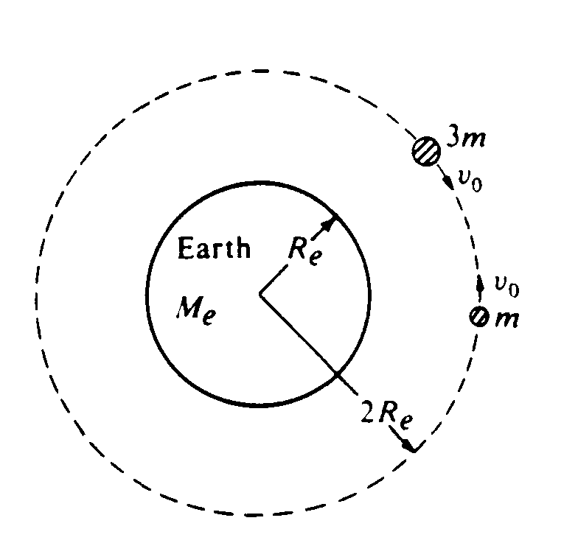
1984M2. Two satellites, of masses m and 3m, respectively, are in the same circular orbit about the Earth's center, as shown in the diagram above. The Earth has mass M_{e} and radius R_{e}. In this orbit, which has a radius of 2R_{e}, the satellites initially move with the same orbital speed v_{o} but in opposite directions.
a. Calculate the orbital speed v_{o} of the satellites in terms of G, M_{e}, and R_{e}.
b. Assume that the satellites collide head-on and stick together. In terms of v_{o} find the speed v of the combination immediately after the collision.
c. Calculate the total mechanical energy of the system immediately after the collision in terms of G, m, M_{e}, and R_{e}. Assume that the gravitational potential energy of an object is defined to be zero at an infinite distance from the Earth.

1984M3. A small body of mass m located near the Earth’s surface falls from rest in the Earth's gravitational
field. Acting on the body is a resistive force of magnitude kmv, where k is a constant and v is the speed
of the body.
a. On the diagram below, draw and identify all of the forces acting on the body as it falls.

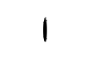

b. Write the differential equation that represents Newton's second law for this situation.
c. Determine the terminal speed v_{T} of the body.
d. Integrate the differential equation once to obtain an expression for the speed v as a function of
time t. Use the condition that v = 0 when t= 0.
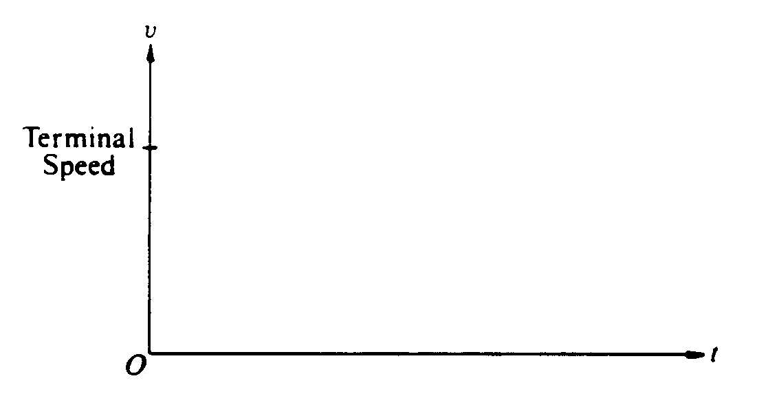
e. On the axes provided below, draw a graph of the speed v as a function of time t.
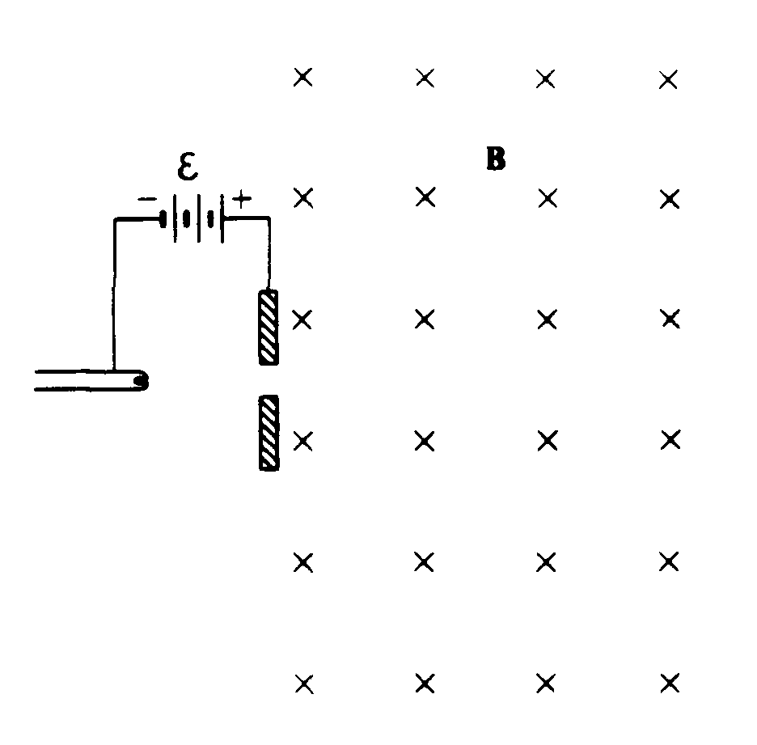
1984E1. An electron from a hot filament in a cathode ray tube is accelerated through a potential difference ε. It then passes into a region of uniform magnetic field B. directed into the page as shown above. The mass of the electron is m and the charge has magnitude e.
a. Find the potential difference a necessary to give the electron a speed v as it enters the magnetic field.
b. On the diagram above, sketch the path of the electron in the magnetic field.
c. In terms of mass m, speed v, charge e, and field strength B, develop an expression for r, the radius of
the circular path of the electron.
d. An electric field E is now established in the same region as the magnetic field, so that the electron
passes through the region undeflected.
i. Determine the magnitude of E.
ii. Indicate the direction of E on the diagram above.

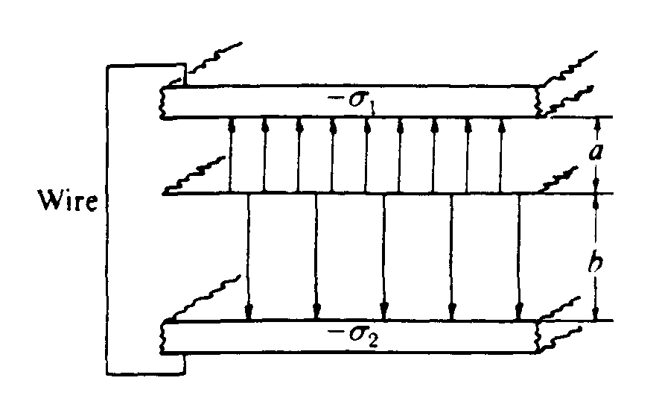
1984E2. Two large, parallel conducting plates are joined by a wire, as shown above, so that they are at the same potential. Between the plates, at a distance a from the upper plate and a distance b from the lower plate, is a thin, uniformly charged sheet whose charge per unit area is σ The electric fields between the plates above and below the sheet have magnitudes E_{l} and E₂, respectively.
a. Determine the ratio E₁/E₂ so that the potential difference between the outer plates is zero.
b. The Gaussian surface in the diagram immediately below has faces of area A parallel to the charged sheet. By applying Gauss's law to this surface, develop a relationship among E_{l}, E₂, a, and any appropriate fundamental constants.
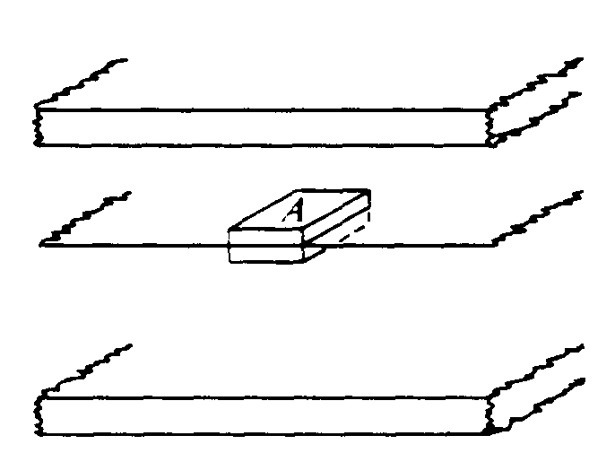

c. By applying Gauss's law to an appropriately chosen Gaussian surface, show that the sum of the induced charge densities, σ₁ and σ₂, on the inner surfaces of the conducting plates equals -σ. Indicate clearly on the diagram below, the Gaussian surface you used.
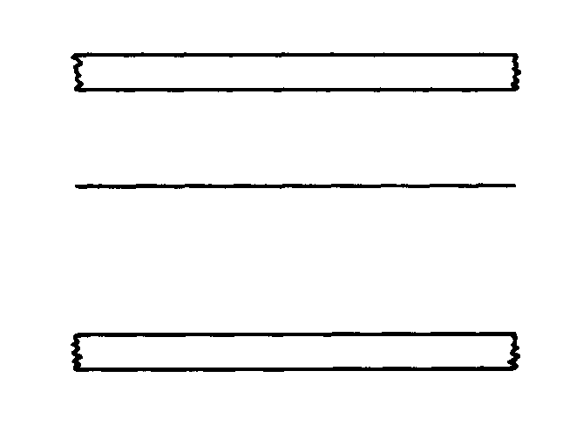
d. Develop an expression for the potential difference V between the charged sheet and the conducting plates in terms of σ, a, b, and any appropriate fundamental constants.

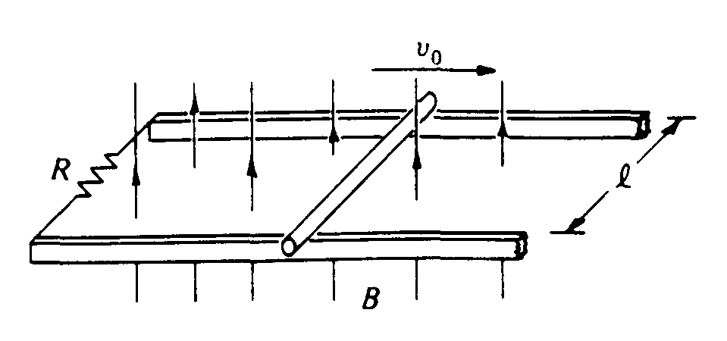
1984E3. Two horizontal conducting rails are separated by a distance l as shown above. The rails are connected at one end by a resistor of resistance R. A conducting rod of mass m can slide without friction along the rails. The rails and the rod have negligible resistance. A uniform magnetic field of magnitude B is perpendicular to the plane of the rails as shown. The rod is given a push to the right and then allowed to coast. At time t = 0 (immediately after it is pushed) the rod has a speed v_{o} to the right.
a. Indicate on the diagram above the direction of the induced current in the resistor.
b. In terms of the quantities given, determine the magnitude of the induced current in the resistor at time t = 0
c. Indicate on the diagram above the direction of the force on the rod.
d. In terms of the quantities given, determine the magnitude of the force acting on the rod at time t = 0.

If the rod is allowed to continue to coast, its speed as a function of time will be as follows.

v = v_{o}e ^{-(B²l²t/Rm)}

e. In terms of the quantities given, determine the power developed in the resistor as a function of time t.
f. Show that the total energy produced in the resistor is equal to the initial kinetic energy of the bar.

